

(South Australian Ice Hockey Association Inc.)
Annual General Meeting for 2013

AGM held on 26th February 2014
Colonel Light Hotel, Light Square, Adelaide
Meeting opened 7:39 pm

1. Present Steve Wise, Matt Wegener, Sue Walker, Nicola Reese, Kevin Brown, Ryan O’Handley, Christian Knott, Steve McGuiness, Jenny Oliphant McGuiness, Neil Boyle, Tristan Reese, Stephen Kilgariff, John McKinlay, Norbert Pesci (non voting), Ross Noga, Pete Boyle, Stephen Campbell, Sarah Wise, Adam Wise, Justine Shaw, Don Rurak, Shirley Rural, Wes Ulrich, Claire Wise, Michael Riley, Josef Rezek, Steve Newbound, Robert Charman, Alexei Filinkov, Bill Newbound, Russell Brewer, Jo Phyllis, Barry McConnery, Matt Gaspari, Amy Newbound, Sami Mantere, Graeme Charbonneau, Chris Parks, Chris Tait, Tom Tait, Candice Mitchell, Chris Moreton, Scott McFarlane, Tom Hill, Peter Taylor, Bill Prentice, Darren Stockburger, Ben Wright, T Baxter, Samara Mihal, Kirsty Venus, Gabby Aston, Mitchell Villani, Andrew Glass, Vince Jukic, Anthony McInerney, Steve Meharry, Sarah Boyce, Simon Kelly

Non voting- Ryan Foll, Wilma Tait, Angela Newbound, Lou Stockburger, Remy McGuiness, Carol Riley, Jake Riley, Michelle Riley, Marcel McGuiness,

Apologies: David Oxlad, Melissa Oxlad, Corey Smith, Sue Hameister, Mick Simmons,
1.2 Minutes of the 2012 Annual General Meeting;
John McKinlay was present but did not sign in, Christian Knott not Knoll misspelt. The previous AGM were presented both as a hand out at this meeting and emailed to members within the required timeframe.
Item 5-financial report to be sent to all those present at the AGM not all financial members
2.1 Errors or omissions:
Month Changed
2.2 Motion: To adopt the minutes of the 2012 AGM.
Moved: Steve Kilgariff
Seconded :Christian Knott
All in favour.
Motion carried
3. Business arising from the minutes:
3.1 Financial report was sent to all members that attended the AGM, not all financial members.
Position statements, states vice president or president reside at tribunal proceedings which is against constitution so needs to be removed-3rd to last dot point
4. Presidents report:

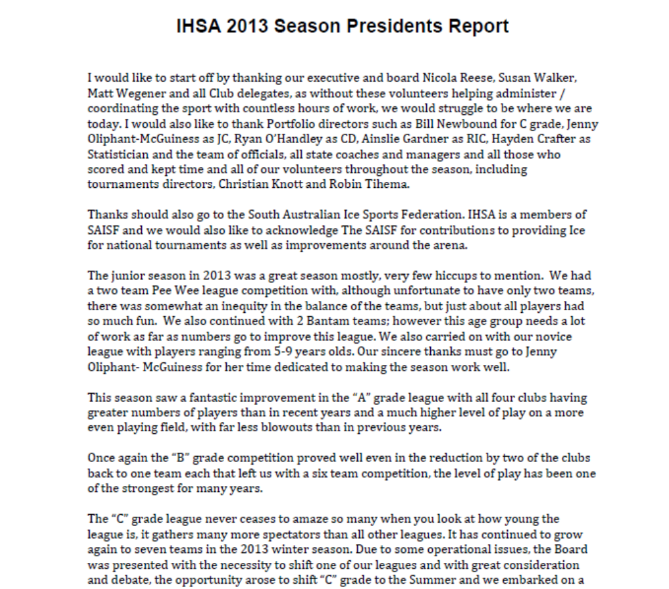
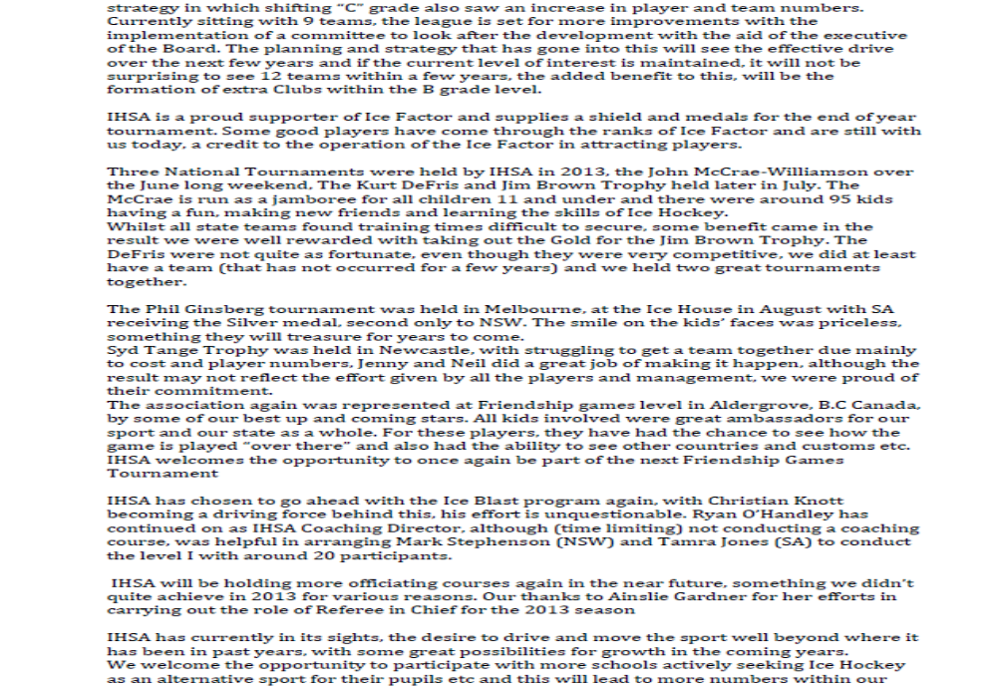
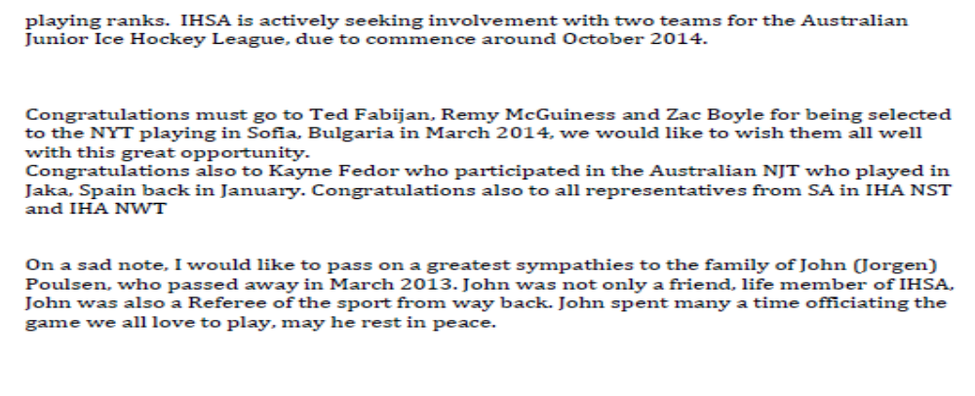

Motion: Moved that the president’s report be accepted.
Moved – Peter Boyle
Seconded- Jo Phyllis
All in favour.
Motion carried
5. Financial report:
Statement from auditor presented, cashflow statement, auditors statement at the back included. No queries
Motion: Financial report be accepted
Moved: Stephen Campbell
Seconded Tristan Reese
All in favour.
Motion carried
6. Election of Members.
6.1 President
Two nominations Steve Wise Nominated by Matt Wegener, seconded by Nicola Reese.
Steve Newbound nominated by Darren Stockburger, Seconded by Sari Lehman.
Both prepared to stand.
Stephen Kilgariff moved a motion for a secret ballot to occur, seconded Glen Foll. Show of hands 28 for motion, 12 against. Other 14 abstained, motion carried.
Non voting members asked to leave while vote taken until count is declared.
Bob Charman and Ross Noga appointed scrutineers.
54 eligible to vote. 51 votes received. Steve Wise 11 votes, Steve Newbound 40 votes. Steve Newbound elected president by majority.
Matt Wegener thanked Steve Wise for all his efforts.
6.2 Treasurer
Nomination received within required time frame from Susan Walker-rescinded.
Steve K asked if Sue Walker would remain in the role until somebody found. Sue will think about it. Steve W thanked outgoing treasurer.
Nomination from the floor for Steve K, Moved Stephen Campbell, seconded Christian Knott, not prepared to stand

7 Adoption of By-Laws- These have been removed from AGM agenda to be dealt with at board meetings.
8. Fees for 2014-have been set already by the board. Fees are to remain the same as 2013 as IHA have not increased there fees and running costs of IHSA have not increased.
9. General Business
9.1 New rink-Leon Bignell at a recent meeting of election parties policies to the sports announced there was a rink potentially at the Wayville Show grounds.
9.2 C grade-is it staying a summer league or going to winter again. Current schedule for winter does not include C grade. Was some previous discussion over changes to the format of C grade and nothing yet put forward as a formal proposal.
9.3 Junior voting rights-how can junior council gain voting rights? Not currently allowed under constitution. At first meeting after 2012 AGM the clubs stepped back from having active votes in all junior matters leaving the majority of decisions to the Executive. Junior Council represents a large portion of the members who currently have no voting representation. To change the constitution would need to put forward at the next AGM or a special meeting. Two scenarios-junior members parents allowed to vote one vote on behalf of minor member or junior council could get a vote. This needs to be researched, suggested a working group to meet and put forward ideas to the board, Junior Council for comment to get a census to put forward either at AGM or special meeting. Need to ensure enough time for juniors. We moved C grade to the summer to get more ice time for development in the winter.
9.4 Congratulations to Josh Harding, Wehebe Darge, Darren Corstens, Greg Oddy and Ben Gebert for making it into the Australian National Senior Team and Charlie Huber to the New Zealand National Senior Team. To Gaby Aston, Candice Mitchell, Michelle Coonan, Tess Reynolds, Kate Tihema and Sari Lehman on making the Australian National Womens team
9.5 Steve Wise congratulated Steve Newbound on his appointment
9.6 Website-sub committee has been formed and meeting has occurred between IHA and IHSA to use pointstreak as the host. As the website is the first contact to IHSA it needs to be upgraded.
9.7 Steve Newbound thanked Steve Wise for over 10 years of service
9.10 Meeting closed at 8:40 pm.

